# Fundamental Release Notes MYSQL to JSON REST API Documentation

## 1.1 Introduction

In order to facilitate communication between the Fundamental Release Notes MYSQL database and the Fundamental Release Notes web app, a simple PHP REST API was implemented.

The REST API returns and writes JSON data to and from the MYSQL database, allowing the JavaScript based (Vue 2) Fundamental Release Notes application to access the MYSQL database.

## 1.2 Usage

The REST API can be used to **list, create, delete, update, read** and **increment** rows in the Fundamental Release Notes MYSQL database via any type source code that can consume an API.

The base API endpoint is: <http://www.fundamental.net/releasenotes/api.php>

In order to see a full list of the available commands of the API, follow the steps below:

1. Go to <http://fundamental.net/releasenotes/frn-api-swagger.yaml> and copy all the text that appears on the page.

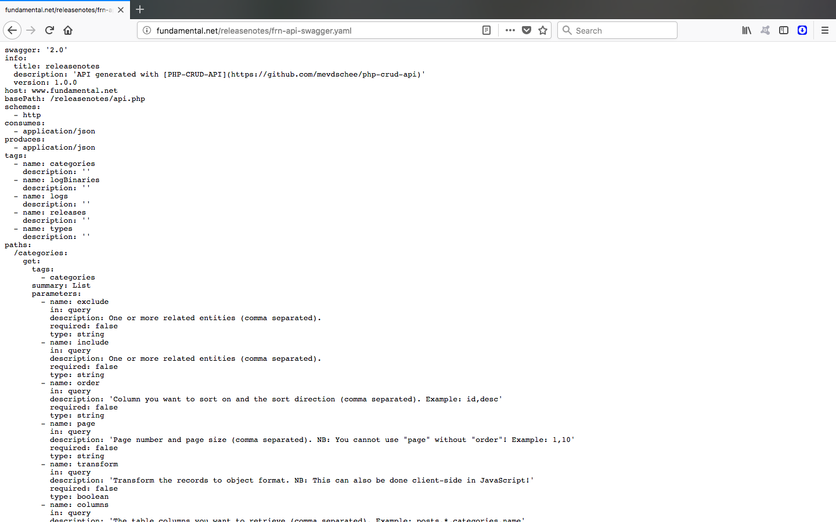

1. Go to <https://editor.swagger.io>. By default, documentation for a ‘Swagger Petstore’ will be shown.

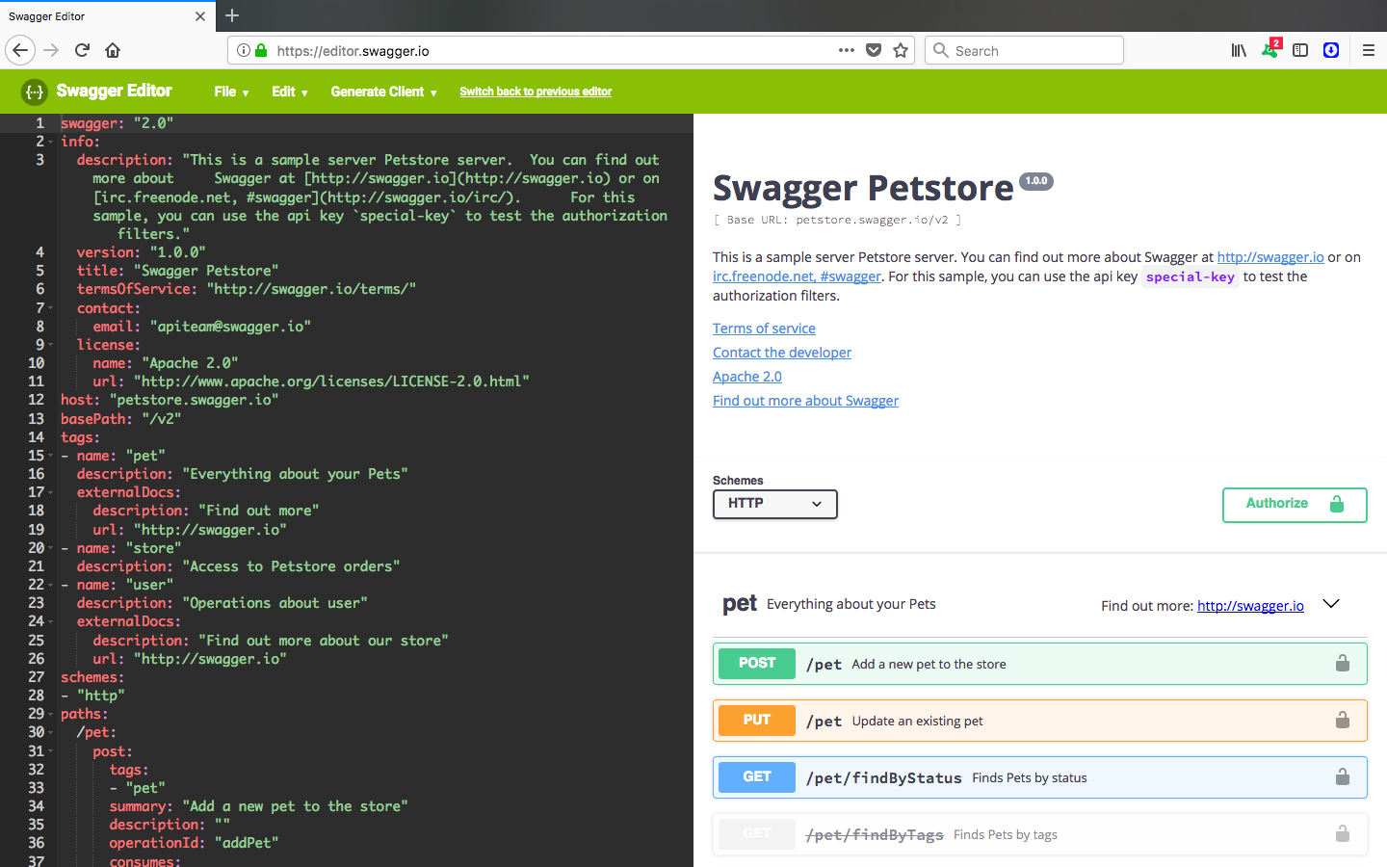

1. In the **menu** at the top of that page, go to **File -> Clear editor,** which will clear all the sample data on the screen  
     
   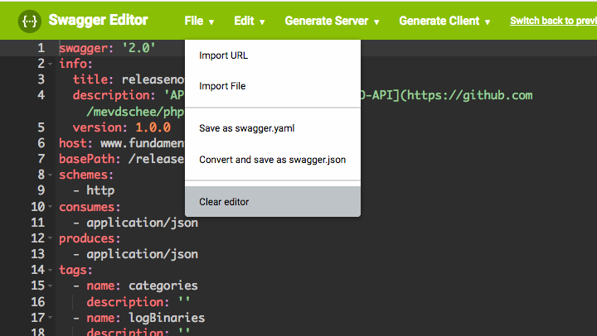
2. On the dark grey panel on the left, paste the text copied in **step 1**.  
     
   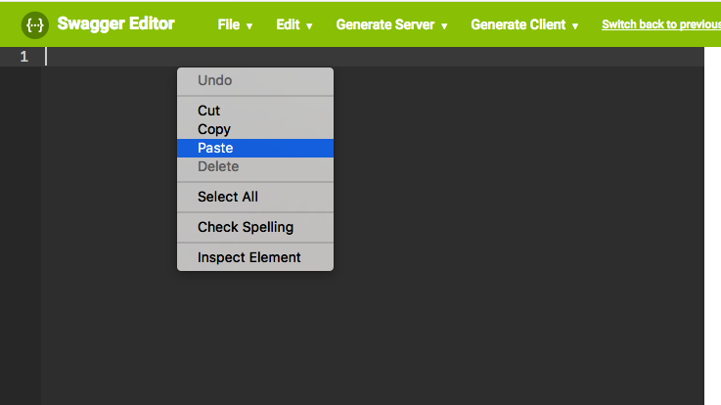
3. **All done**! All the available API functions and their request and response objects related to the API will be listed on the right hand side.  
     
   